***Magnus Effect***

Hello Jussties, how’s the day going hope its great. Have you ever thought why some balls follow a curved path in air, tennis, cricket and football players experience this.In old days some bowlers scratch any particular side with accessories like ring etc, but it’s illegal, to make the **ball swing**, you must have seen **freekicks in footballs** in which the players kick the ball in a way that it bends its path and this is nicknamed as “**Banana Shot**”, in tennis they say that they **chop the ball** which really doesn’t mean that they are cutting the ball into pieces but it means that they are **curving the trajectory**(path followed by an object)of the **projectile**(the object which is thrown or in motion). All this is due to **Magnus effect**, “So first of all what is Magnus effect?” This is what you right? I got you ☺

# Magnus Effect:

It is a phenomenon that is commonly associated with a **spinning object moving in a fluid medium**. It is a **manifestation of Bernoulli’s theorem**

Let me try to convey this in a **lucid language** as usual let’s assume a football is kicked by a professional player say you, in a way that it spins in clockwise direction and **air flows in the opposite direction**.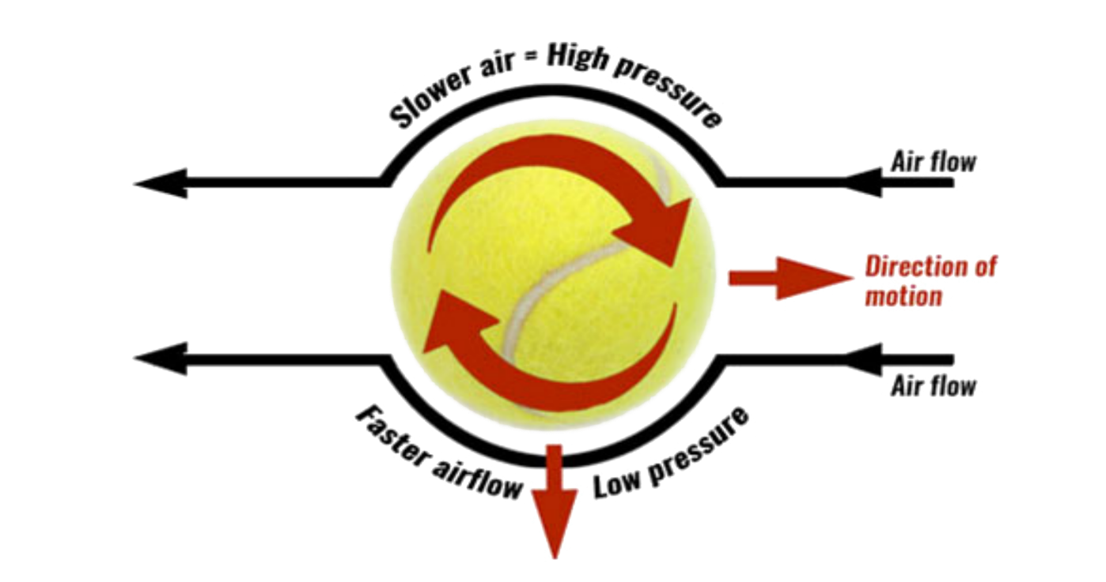

Credits for the pic: **TeachPE.com**

Due to the **drag** of the air (as the wind is in opposite direction an opposite force is acted on the projectile) the **speed at the upper side** of the ball **decreases** and the **speed at the lower side increases**, because of this a **pressure difference** increases. We know that the Bernoulli’s theorem states that if the **speed of the fluid is less then high pressure** is created there if the **speed increases then low pressure** is created. This pressure difference exerts a force on the object and **curves its path**. In our case it **bends downward**. This is known as Magnus effect. Now some of you couldn’t figure out why the pressure decreases,let me clarify it with another example, sometimes when you **stand near the track** in a metro or railway station when the **locomotive** or the train passes you with **high speed** you might feel **something behind you pushing** you towards the track, the same acts here(But please **don’t try this** at any circumstance).

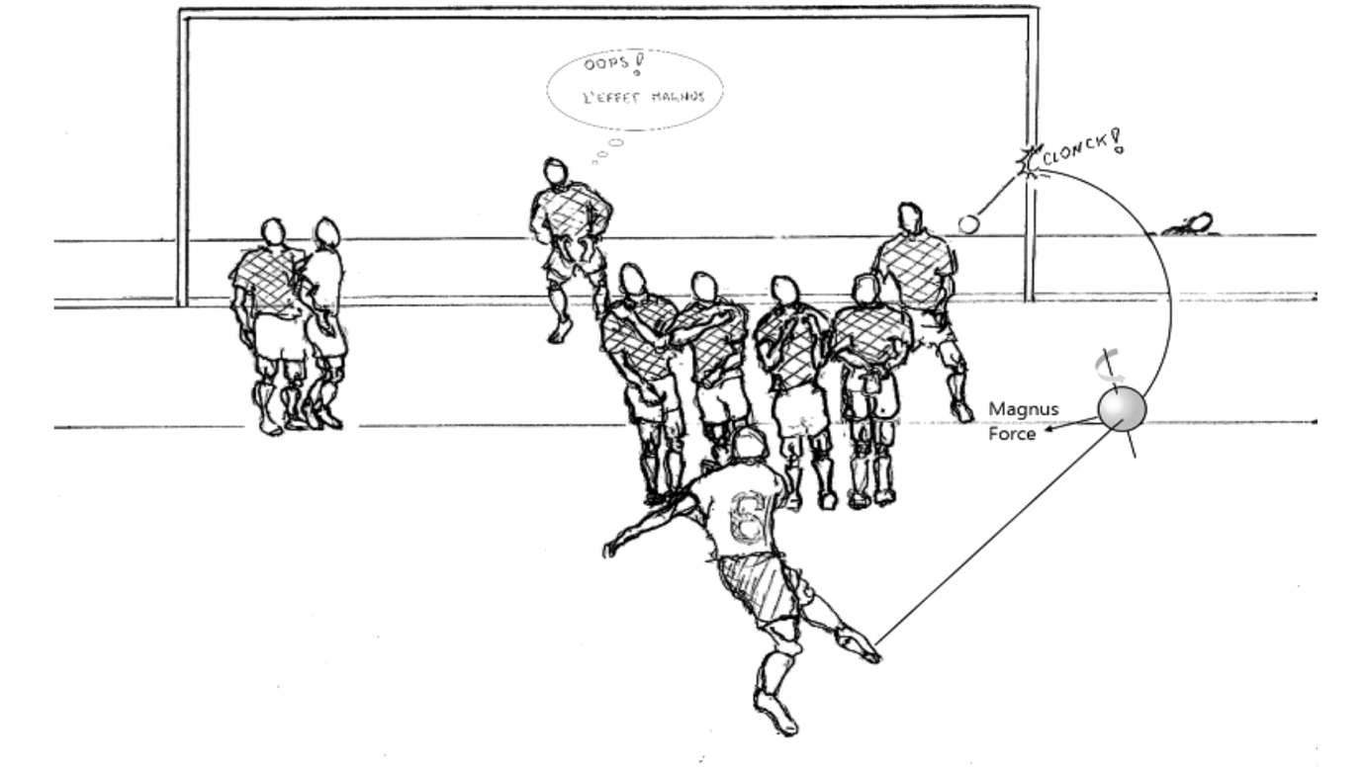

Credits for the pic: **COMSOL**

For the first time in the history of football in the match of **France VS Brazil** in **1997** a player named **Roberto Carlos** made a kick in which the ball curved as illustrated above. The Audience were stunned on seeing this and till now no one could make a banana shot as good as Carlos. At last a **fun fact** Roberto Carlos has also **played in Indian Super League** for one season in **2015** and he had also acted as a **player manager for Delhi Dynamos** and led them to playoffs.

***Thank You***